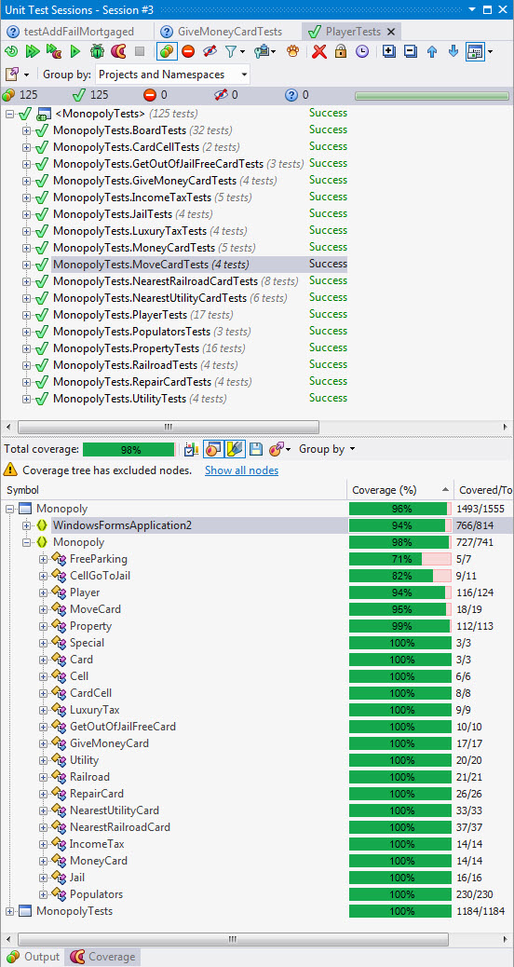Final Report

David Gartzke, Brodie Lockard, Francis Meng

**Progress this week**

Drawn card dialog box, using Get Out of Jail Free card, a debug tool for giving a specific player a specific card, and finished internationalization.

**Code Coverage**

98%, specific data to the right.

**Lines per team member**

David ~ 200

Brodie ~ 125

Francis ~ 250

**UML diagram**

(page 3)

**Metrics**

(attached in excel sheet)

**Video**

**All features implemented**

* Rolling dice and displaying the outcome on the board
* 2-4 player capabilities
* Winning and losing
* Buying, trading, and mortgaging properties
* Monopolies and buying houses and hotels
* Displaying houses and hotels
* Paying rent
* Gaining and losing money
* Bankruptcy
* Community Chest and Chance cards
* A controlled roll
* Giving specific cards to specific players
* Going to jail, with the cards, the square, and rolling doubles 3 times in a row
* Getting out of jail with paying the fine, rolling doubles, or the get out of jail free card
* Free Parking
* Collecting $200 when passing GO
* Internationalization for both English and Chinese

